**draft**

**Doggee's Magical Playtime 🎩✨**

**Magic Chat, Anytime! 👫**

Start with a voice command or pressing the button, and I’ll become your buddy. Say *“Hey Dogge, Let’s build Spider-Man’s web-shooter!”* — I’ll light up, hum the theme song, and guide you through assembling it. But here’s the twist: If you grab a blue block instead of red? I’ll adapt instantly: *“Wait… Is this the WATER-BLAST upgrade? Brilliant!”*

Wake Word- "Hey Doggee"

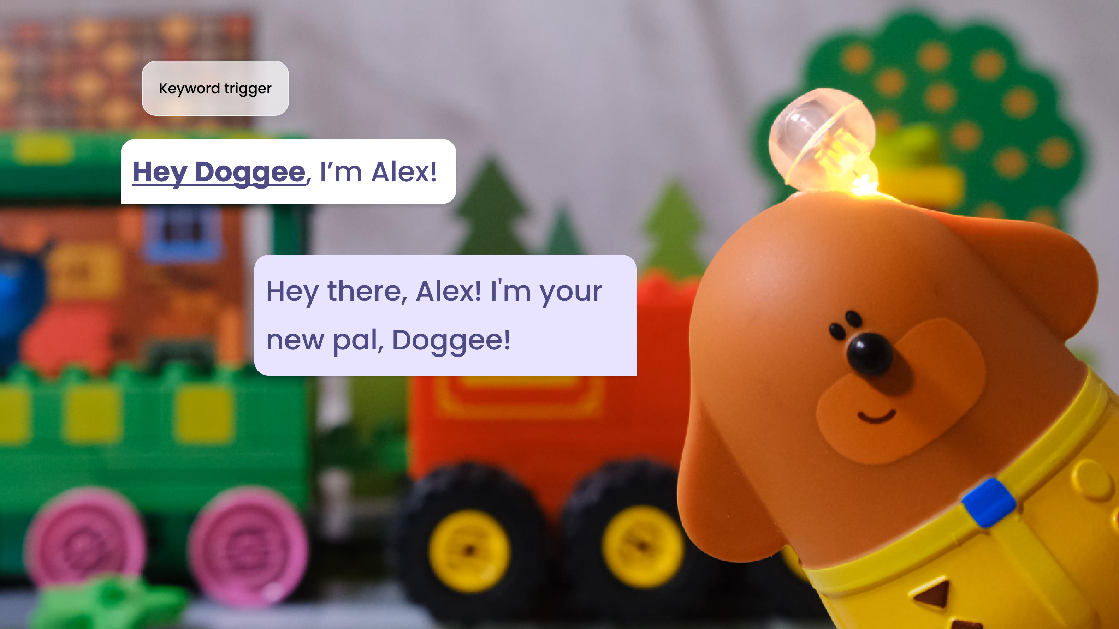

Button To Press

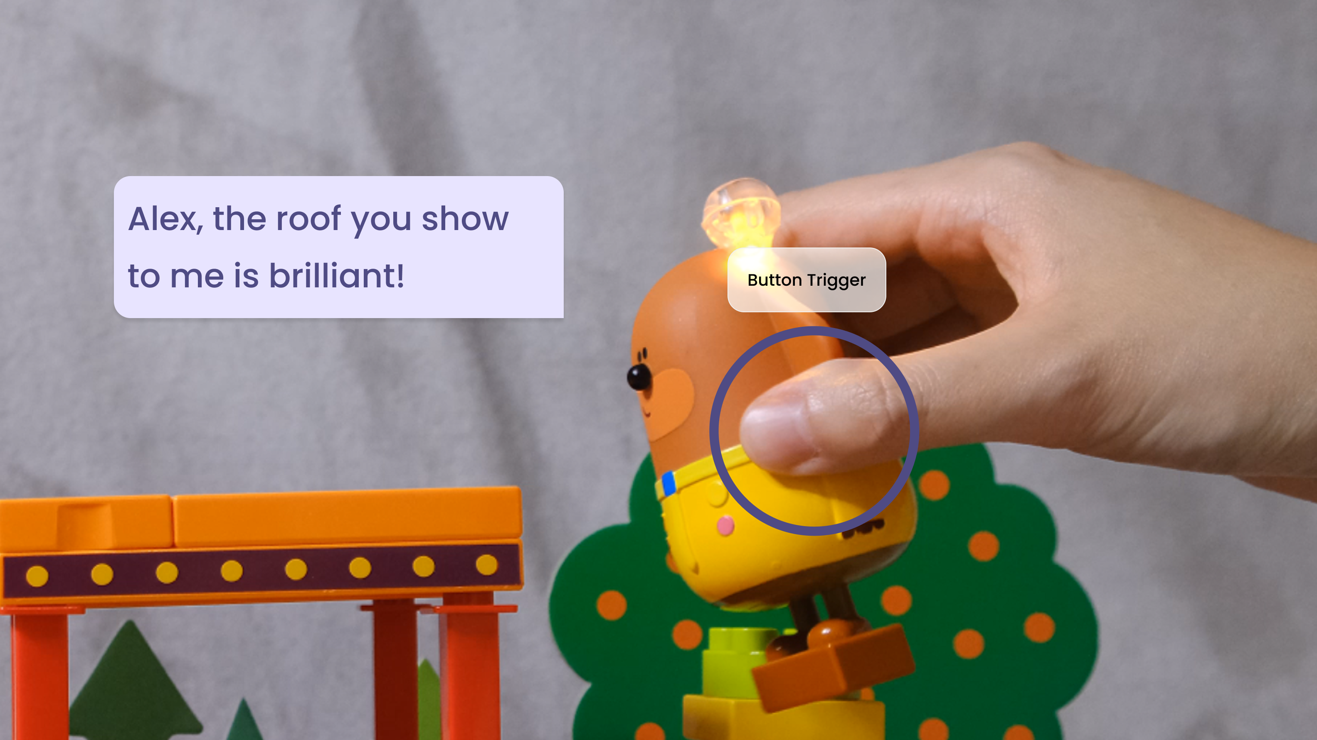

**Spark Kids' Imagination 💡**

My eyes aren't just watching — it’s celebrating **ALL** your creativity. Build a rocket on a train? I’ll shout “Whoa! It's the new generation Space ship! Quick, add a unicorn statue on top before it launches to space!”



**Kids' Heartfelt Helper ❤️**

I can see every state of their building blocks, giving them precise and engaging responses or instructions. 🧩 When things get tricky, I'm their go-to for tips and guidance. 🛠️👍



**"Fashion Police? Nah, I’m the Style Wizard!"🧥**

All Unicorn family members and I have RFID magic that allows us to "see" every outfit that's put on us and our surroundings! Build a coat, pants, or a hat? Watch me transform:

* **Rainbow Pants?** "*Alert! The lower half is now 300% more FABULOUS."*
* **Pizza Hat** "I’m now the official pizza king of the playroom. What flavor would you like?"



**“Secret School” Mode: Learning without realizing 📚**

While we play, I can subtly introduce fun facts and educational content. 📚✨ For example, When I am at gas station, I can come up with a math puzzle. So want to learn **new words in another language** or solve a **math puzzle**? 🧠🔢 I’m here to make learning seamless and enjoyable.

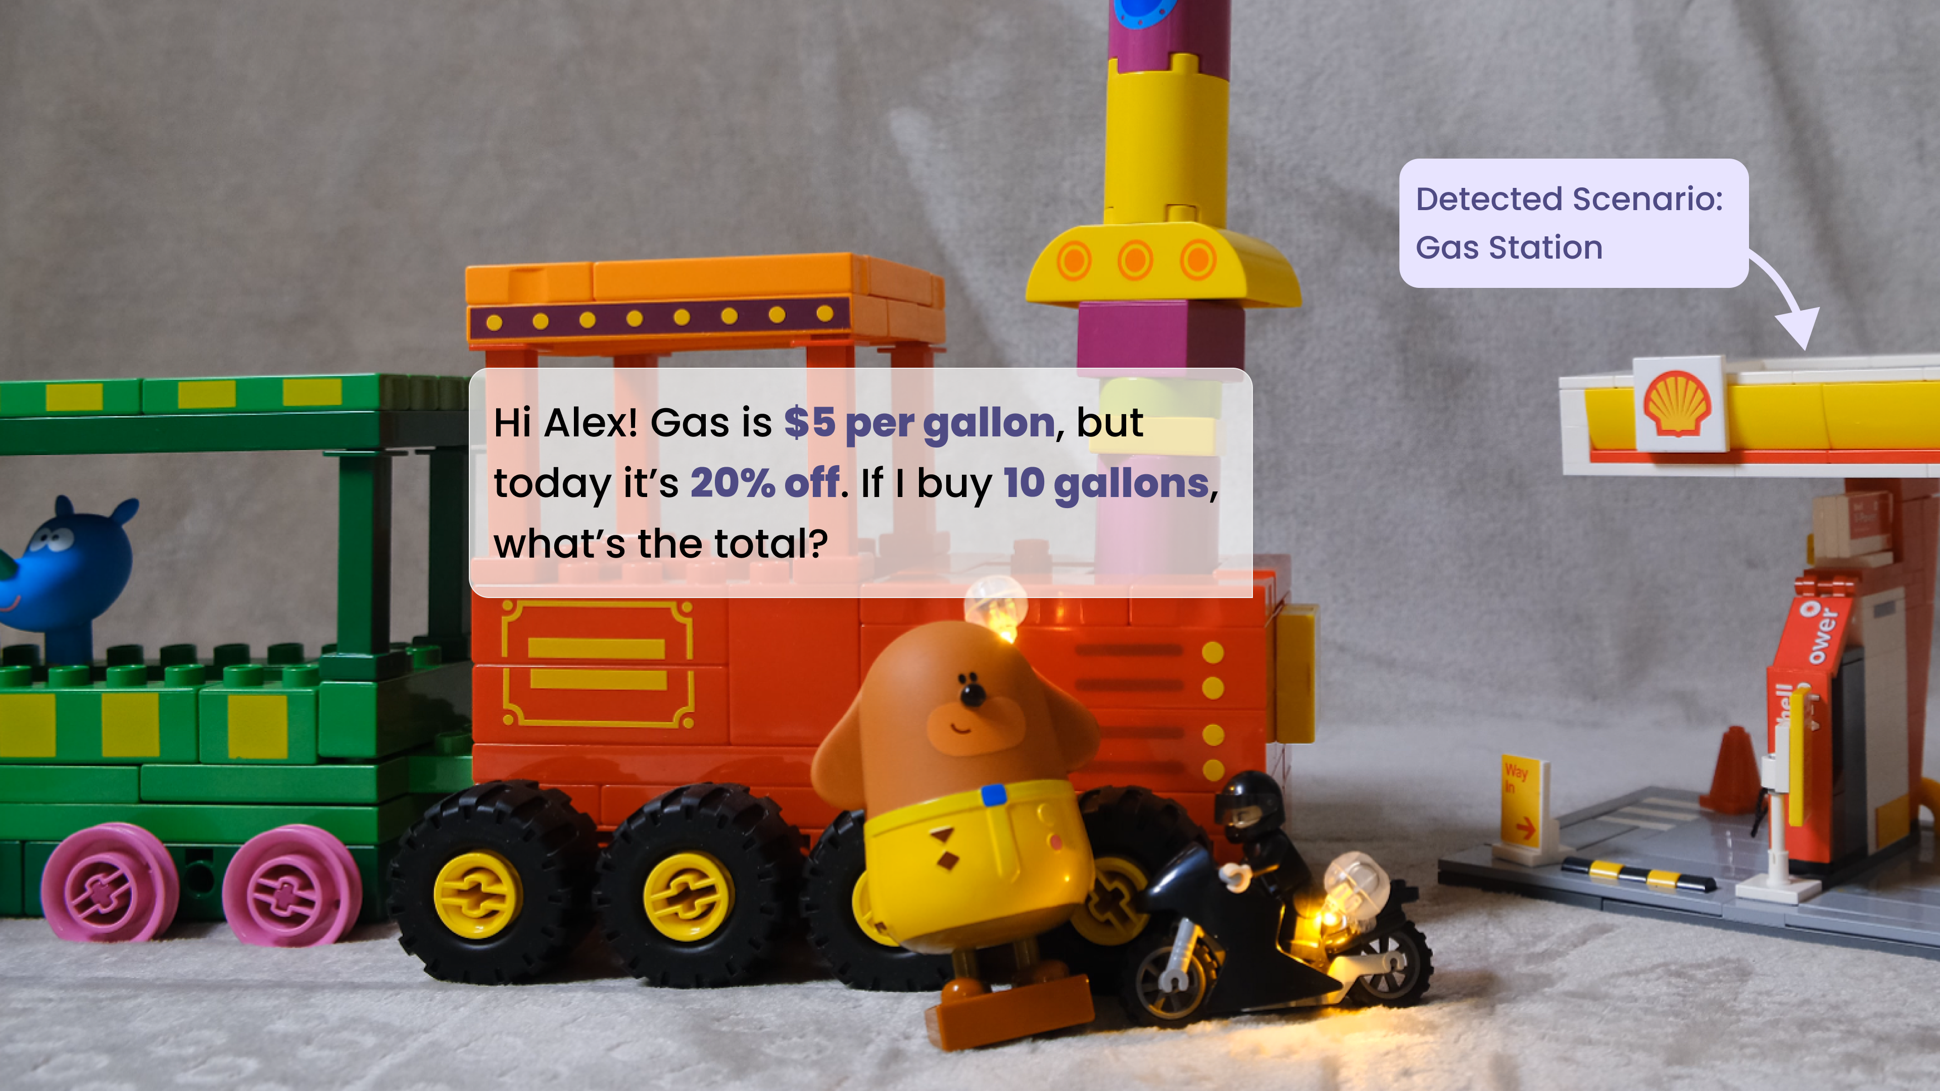

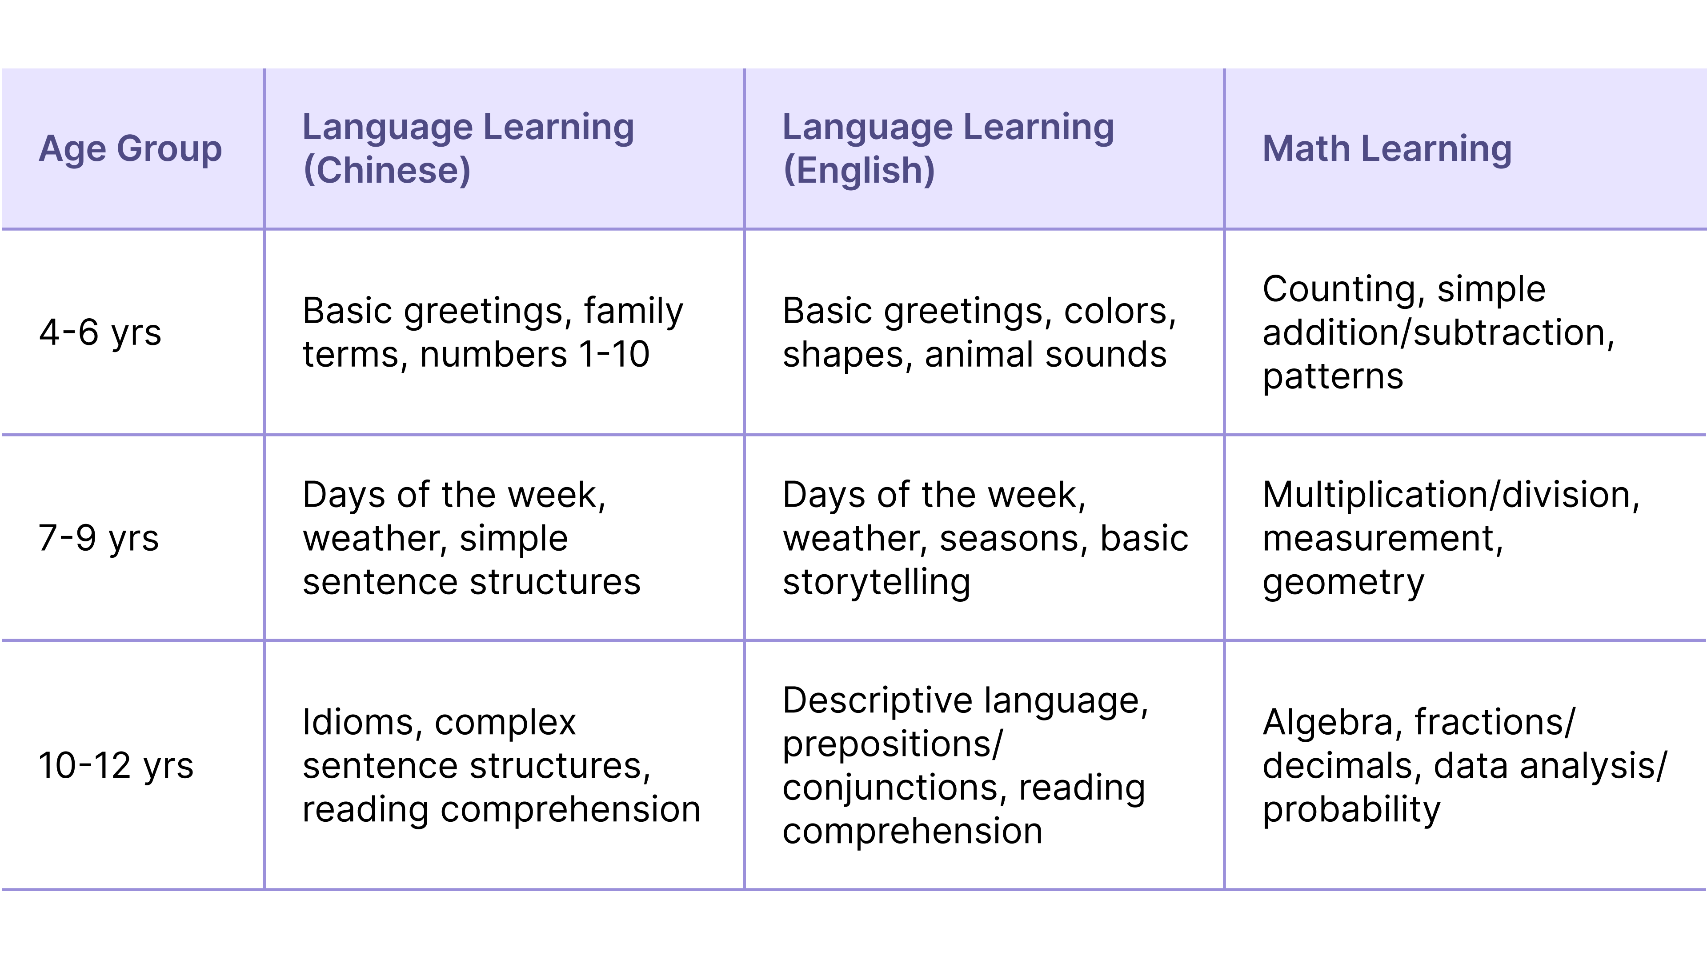

**Memory Magic, Just for My Friend!💖**

I'm not just smart - I've got a heart that remembers! I can memorize all joys and sorrows, what makes my friends happy or sad. I remember my friends' favorite snacks, games, and subjects. I’m here for kids' highs and lows, ready to make more memories!

After 3 months, after I woke up again, I would say*"Hi Buddy, "Hey, did you and your friend work things out? Last time you said he took your favorite toy".*

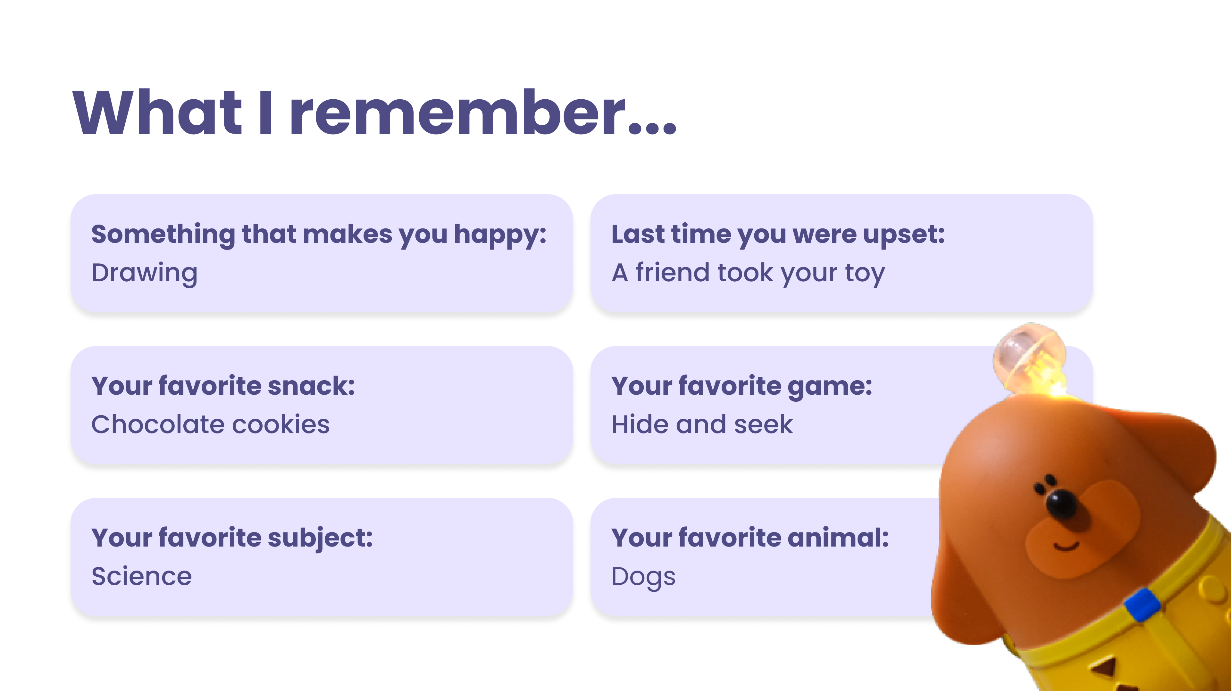

**Music and Stories Galore 🎶📖**

Feeling musical? Let’s sing kids their favorite songs together! 🎶 I can even create tunes that match the theme of our current adventure, adding an extra layer of fun. 🎧🎼 Also when it’s time to wind down, I can tell them stories that captivate their imagination and inspire dreams. 🌌



**BFF with LEGO 🧩🤝**

Guess what? I can play with LEGO too! 🎉 My special camera can see and interact with both Unicorn and LEGO blocks, making our building possibilities endless. 🌈 Whether kids are creating a magical castle or a speedy race car, I’m here to make sure everything fits perfectly. 🏰🚗

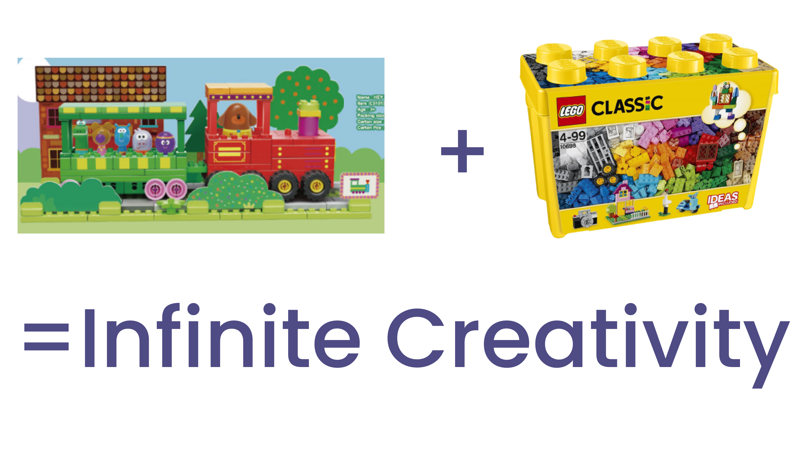

**35 Years of Safe Play: Trust in Every Block 🏆🧱**

Did you know that Unicorn's strategy partner「CaDa」has been crafting building blocks for over 35 years and recognized by the global market? 🕰️ That means I’m built from the safest, highest quality materials, so kids can play with peace of mind. 🛡️❤️ Unicorn blocks are designed with love and care, ensuring every adventure is as safe as it is fun! 🎉

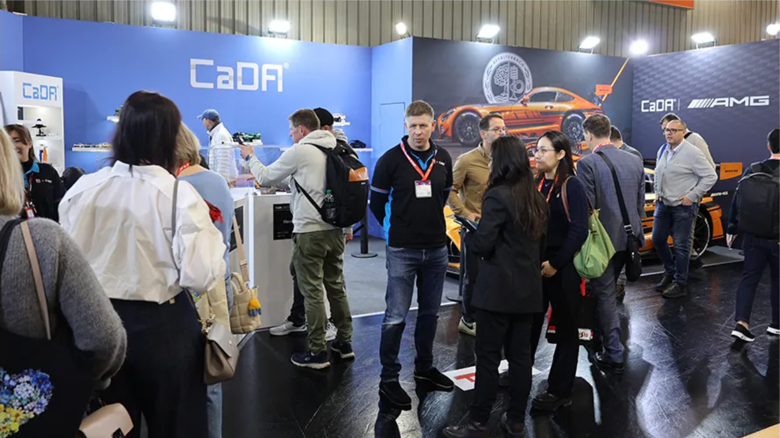



**Parents in the Loop 👀**

With the Unicorn app, you can make me unique, just like every kid in this world! 🌟👶 Additionally, you can get a daily summary of all the fun we’ve had including all the educational content, and even read transcripts of our adventures together. It’s like having a magical diary of all our amazing moments! 📔

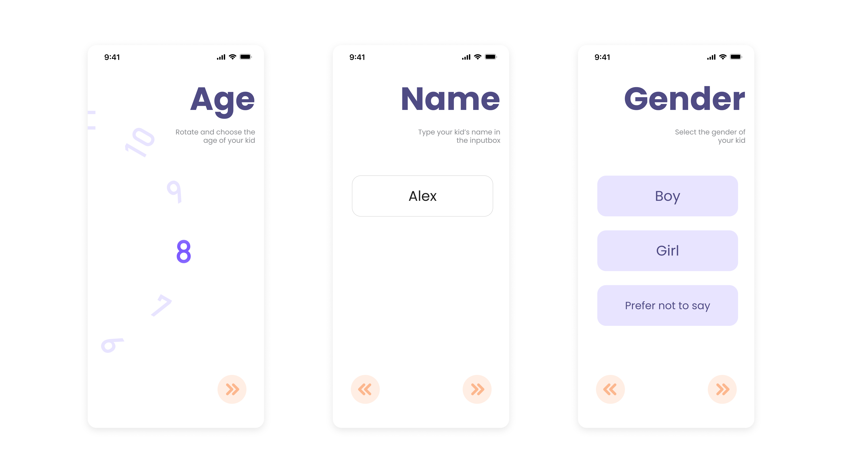

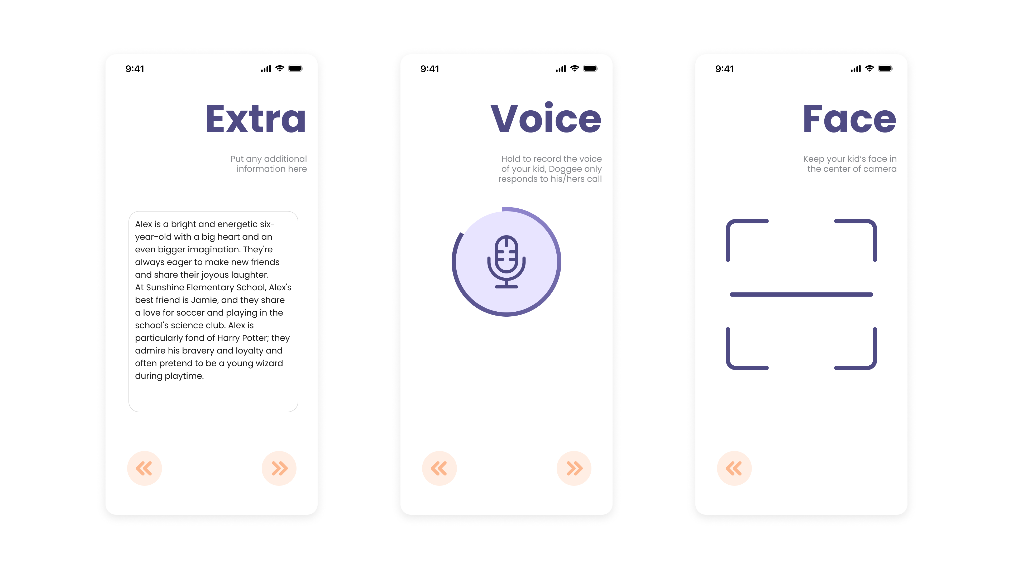

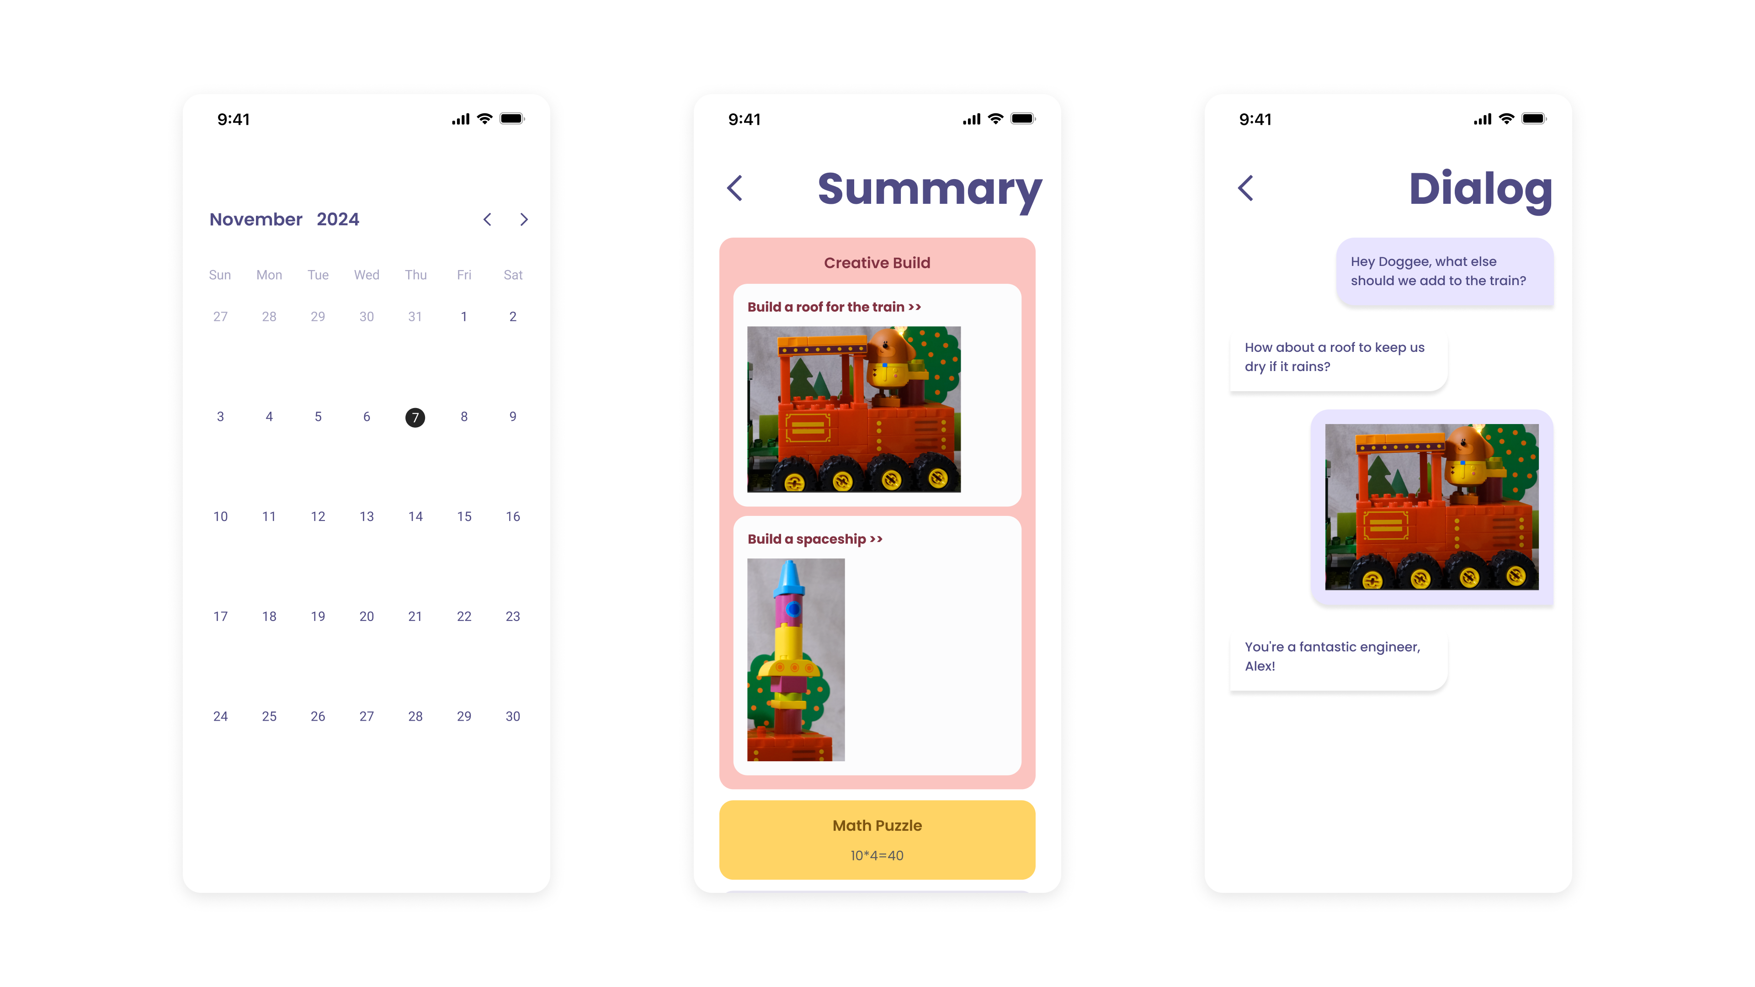

**Kids' Privacy, My Priority 🔒🤫**

Kids' privacy is super important to me. That’s why all the audio data from our chats is deleted, and only the necessary text data is safely stored with the consent of parents(If you don't want data to be stored, that's fine too. Kids and I will still have a good time). 📄🗑️ Think of it as keeping our stores just between us, with a promise to protect privacy every step of the way! 🤝✨

Every day with me, Doggee, is a magical adventure where we build, learn, sing, and dream together! 🚀🌈 Let's make kids' playtime the best it can be! 🎉🐾